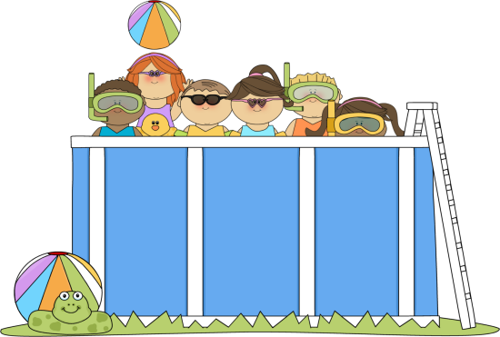 **Summer Reading Activities** 

**For Incoming First Graders**

Each time you complete a reading activity, color in the box.

|  |  |  |  |
| --- | --- | --- | --- |
| Read a book  in bed. | Read a book in the bathtub. | Read a book to a family member. | Read a book outside. |
| Read a book to a stuffed animal. | Read a book over the phone or on Facetime/Skype to someone. | Read a book about an animal. | Read a non-fiction book. |
| Read a book to a friend. | Play a reading game on **abcya.com.** | Read a book about friends. | Read a book with a flashlight. |
| Read a book about school. | Read a book about your favorite season. | Read a book together as a family. | Read a book about sports. |
| Read a funny  book. | Read a book that a parent/family member picks for you. | Read a book with a color word in the title. | Play a reading game on **pbskids.org** |
| Read a new book by an author that you have already read before. | Read a book under a tree. | Read a fairy tale book. | Use the template on the next page to create an ice cream cone book report. Please feel free to make a larger copy or use other paper to complete the task. |

Parent Signature: ________________________________

HerestheScoop.pdf

Title:

Author: