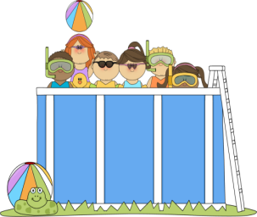 Summer Literacy Activities
For Incoming Second Graders
Each time you complete a reading activity, color in the box.

Read a book  in bed. | Read a book in the bathtub. | Read a book to a family member. | Read a book outside.
Read a book to a stuffed animal. | Read a fairy tale book. | Read a book about an something you like. | Read a non-fiction book.
Read a book to a friend. | Play a reading game on abcya.com. | Read a funny  book. | Read a book with a flashlight.
Read a book about school. | Read a book under a tree. | Read a book together as a family. | Play a reading game on pbskids.org
Read a new book by an author that you have already read before. | Read a book that a parent/family member picks for you. | Read a book over the phone or on Facetime/Skype to someone. | Complete an ice cream book report. (template available on through the summer work link).
Read a book of poetry. | Read something that came in the mail. | Read while eating breakfast. | Read signs as you are in the car.
Help write the grocery list. Help use the list to grocery shop. | .Read a recipe while helping to make food with a grown up. | Tell someone the title and author of a book you read. | Tell someone about the characters in a book your read.
Write your birthday. | Write your address. | Write a letter or postcard to a friend or teacher. | Write a story about something you did this summer.

Parent Signature: ________________________________

